Du Bois, W.E.B. (1868-1963)

W.E.B. Du Bois is the most significant critical writer on race and culture in the twentieth century. Du Bois characterized the issue of race in the United States as “the problem of the color line,” a term itself that points to the nuance of Du Bois’s thinking; the problem was not one race or the other, but the abstract barrier between races that needed to be addressed. Over the course of his illustrious career, Du Bois’s thinking on race evolved: from writing in the social sciences to writing political propaganda, and from thinking of the “Negro problem” regionally (Philadelphia and Atlanta) and nationally to globally (“Pan-Africanism”). Du Bois is popularly credited as the founder of modern civil rights movement because, co-founding the NAACP, he espoused tactics of active agitation and civil disobedience as the more effective route to gain rights and recognition. However, because he ultimately considered capitalism incapable of offering true equality and freedom for minorities, Du Bois’s pivot late-in-life towards Marxist ideology (he joined the Communist party in 1961) ultimately contributed to a murky legacy in the United States. Du Bois self-exiled to Ghana late in life, which also became his final resting place in 1963.

Du Bois was born in Great Barrington, Massachusetts, where his upbringing in a mostly white culture contributed to one of his most significant theoretical contributions to race: the theory of double-consciousness. Synthesized from an allegorical-autobiographical childhood story about a young girl who refused his visiting card “peremptorily, with a glance,” Du Bois articulates the experience of understanding that he was an Other: “It is a peculiar sensation, this double consciousness, this sense of always looking at oneself through the eyes of others, of measuring one’s soul by the tape of a world that looks on in amused contempt and pity. One ever feels his two-ness, --an American, a Negro; two souls, two thoughts, two unreconciled strivings; two warring ideals in one dark body, whose dogged strength alone keeps it from being torn asunder” (*Souls of Black Folk,* 4).

Du Bois received his B.A. from the historically black Fisk University in Nashville, TN, before persevering through an immense struggle to become the first African-American to receive a PhD from Harvard University. There, he befriended and learned from psychologist William James, and, under the tutelage of the historian Albert Bushnell Hart, wrote and published his dissertation, *The Suppression of the African Slave Trade to the United States, 1638-1870*. While working as an “investigator” at the University of Pennsylvania, Du Bois researched and wrote his first seminal work, *The Philadelphia Negro*: a sociological examination of the black population of Philadelphia. This academic work reflected Du Bois’s early belief that racism could be dismantled through intelligent, rational discourse, a belief that would be immediately challenged after he accepted an appointment at Atlanta University. When an impoverished local black man was accused of murder, Du Bois prepared a “careful and reasoned statement concerning the evident facts” to publish in the *Atlanta Constitution,* only to discover that the accused Sam Hose was quickly lynched and this very newspaper promoted the event. Du Bois wrote of this time: “Two considerations thereafter broke in upon my work and eventually disrupted it: first, one could not be a calm, cool, and detached scientist while Negroes were lynched, murdered and starved; and, secondly, there was no such definite demand for scientific work of the sort that I was doing” (*Autobiography,* 221-222). Instead, Du Bois began work on one of the most widely referenced books of the twentieth century, *The Souls of Black Folk* (1903). This combination of essays, histories, and memoirs combats racism through propaganda and marks Du Bois’s pivot towards political writing. As we writes, “The cure wasn’t simply telling people the truth, it was inducing them to act on the truth” (*Dusk of Dawn,* 94). Du Bois applied this political activism to much of the work he would produce thereafter, including his noteworthy historical study *Black Reconstruction* (1935) on the critical function blacks played in the rebuilding of Southern economy and culture after the Civil War.

One of Du Bois’s landmark essays, “The Talented Tenth,” reflects this turn to political engagement. In stark contrast to Booker T. Washington, who believed that through technical education and the gradual accumulation of capital African-Americans would assimilate with white culture and enjoy equal rights, Du Bois argued that African-Americans needed to organize their own liberal arts colleges, newspapers, and businesses, enabling the most talented to succeed and lead. Coinciding with this argumentation, Du Bois advocated for black artists who similarly integrated black culture into their aesthetics, whether in style, phraseology, or themes, like Langston Hughes, Claude McKay, and Zora Neale Hurston (“The Younger Literary Movement”).

**Selected List of Works**

Non-fiction

*The Suppression of the African Slave-Trade to the United States of America, 1638-1870* (1896)

*The Philadelphia Negro* (1899)

*The Souls of Black Folk* (1903)

“The Talented Tenth,” *The Negro Problem* (1903)

*Darkwater: Voices from within the Veil* (1920)

*The Gift of Black Folk: The Negroes in the Making of America* (1924)

“The Negro Mind Reaches Out,” *The New Negro: An Interpretation* (1925)

*Black Reconstruction* (1935)

*Black Folk, Then and Now* (1939)*,* revised and expanded version of *The Negro* (1915)

*Dusk of Dawn: An Essay Toward an Autobiography of a Race Concept* (1940)

“My Evolving Program for Negro Freedom,” *What the Negro Wants* (1944)

*Color and Democracy: Colonies and Peace* (1945)

*The Autobiography of W.E.B. Dubois:**A Soliloquy on Viewing My Life from the Last Decade of Its First Century* (1967)

Novels

*The Quest of the Silver Fleece* (1911)

*Dark Princess: A Romance* (1928)

*The Black Flame* trilogy (1957-1961)

**Further Reading**

Bass, Amy. *Those about Him Remained Silent: The Battle over W.E.B. Du Bois*. Minneapolis:

University of Minnesota, 2009. Print.

Gooding-Williams, Robert. *In the Shadow of Du Bois: Afro-Modern Political Thought in America*.

Cambridge, MA: Harvard UP, 2009. Print.

Lewis, David L. *W.E.B. Du Bois: A Biography 1868-1963*. New York: Holt, 2009. Print.

Sundquist, Eric J., ed. *The Oxford W.E.B. Dubois Reader*. New York: Oxford UP, 1996. Print.

Zhang, Juguo. *W. E. B. Du Bois: The Quest for the Abolition of the Color Line*. New York:

Routledge, 2001. Print.

© Vincent Haddad, Wayne State University

**Images:**

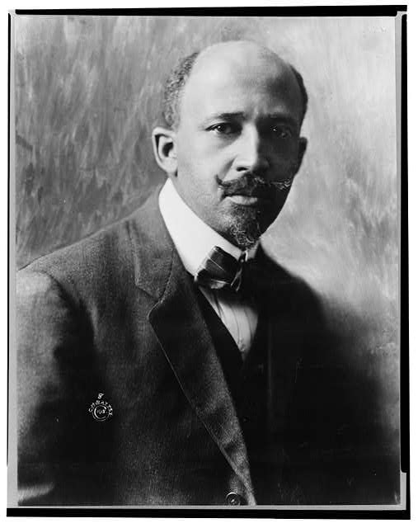

**Du Bois Portrait:**

* **Digital ID:** (digital file from b&w film copy neg.) cph 3a53178 http://hdl.loc.gov/loc.pnp/cph.3a53178
* **Reproduction Number:** LC-DIG-ppmsca-38818 (digital file from original item) LC-USZ62-16767 (b&w film copy neg.)

**Repository:** Library of Congress Prints and Photographs Division Washington, D.C. 20540 USA http://hdl.loc.gov/loc.pnp/pp.print

**Notice to Lynch Sam Hose (included as PDF in e-mail)**

DETERMINED MOB AFTER HOSE; HE WILL BE LYNCHED IF CAUGHT

The Atlanta; Apr 14, 1899; ProQuest Historical Newspapers Atlanta Constitution (1868 - 1939) pg. 1